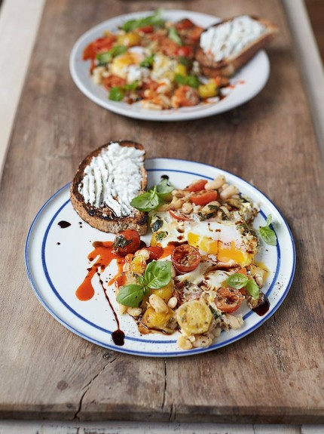
Baked eggs in popped beans

Serves 2

- 250 g mixed-colour ripe cherry tomatoes
- ½ a lemon
- extra virgin olive oil
- 4 sprigs of fresh basil
- 1 x 400 g tin of cannellini beans
- 1 good pinch of fennel seeds
- 2 large free-range eggs
- 2 slices of seeded wholemeal bread
- 2 heaped teaspoons ricotta cheese
- thick balsamic vinegar , optional
- hot chilli sauce , optional

- Halve the tomatoes, place in a bowl and toss with the lemon juice,
- 1 tablespoon of oil and a pinch of sea salt.
- Pick, tear and toss in the basil leaves (reserving the smaller ones for garnish), then leave aside to macerate for a few minutes.
- Meanwhile, place a large non-stick frying pan on a high heat.
- Drain the beans and put into the hot pan with the fennel seeds and a pinch of black pepper. Leave for 5 minutes, shaking occasionally – you want them to char and pop open, bursting their skins.
- Pour the macerated tomatoes into the pan with 100ml of water, season, then leave to bubble away vigorously for 1 minute.
- Crack in an egg on each side, then cover with a lid, plate or tin foil,
- reduce to a medium-low heat and slow-cook for 3 to 4 minutes for nice soft eggs, or longer if you prefer.
- Meanwhile, toast the bread.
- Divide the ricotta and spread over the two pieces of hot toast, then serve on the side of the baked eggs in beans.
- Sprinkle the reserved baby basil leaves over the top .finish with a drizzle of balsamic vinegar and/or a drizzle of hot chilli sauce if required

